**SPL-1 Project Report, 2023**

**EQUATION MASTERMIND**

**SE 305 : Software Project lab 1**

Submitted by

**Md Jihad Hossain**

**BSSE Roll No. : 1413**

**BSSE Session:2021-22**

Supervised by

**Dr. Md. Shariful Islam**

**Professor**

**Institute of Information Technology**



**Institute of Information Technology**

**University of Dhaka**

[13-12-2023]

0

**Prepared by:**

**Md Jihad Hossain**

BSSE 14thbatch

Roll -1413

**Supervised by:**

**Dr.Md.Shariful Islam**

Professor

Institute of Information Technology,

University of Dhaka.

**Submission Date :** 13 th December, 2023

**Supervisor’s Approval:**

______________________________

(Signature )

1

Table of Contents

1. Introduction …………………………………………………………………………………………………………….......3 1.1 Background Study…………………………………………………………………………………………………………3 1.2 Challenges …………………………………………………………………………………………………………………..6

2. Project Overview & Description …………………………………………………………………. 6

2.1 Separate Number and Variable 6

2.2 Solution of Linear Equation 6

2.3 Infinity / No solution Existence 7

2.4 Solution of Polynomial Equation 7

3. User Manual ……………………………………………………………………………………………………………...... 9 4. Conclusion …………………………………………………………………………………………………………….........13 Reference ……………………………………………………………………………………………………………………14

2

**1. Introduction**

*“Equation Mastermind”* solves mathematical equations & show solution process. In this project,I made an equation solver that can solve two kinds of equations. They are,

(i) Linear Equation

(ii) Polynomial Equation

These types of equations are commonly used in our everyday life. It takes input from the user and solves the equation using some algorithm and prints the result.It shows the solution of equations . This program takes input from the I/O console and prints it on the I/O console. This program takes input equations from users in any format. It can help students find the root of these equations and also help to know how to solve them.

**1.1 Background Study**

To understand this project, some prior study was necessary. These topics are included here.

**1.1.1 Determinant of Matrix**

The determinant is defined as a scalar value that is associated with the square matrix. We find to determinant when the matrix is only square. We use the *row reduction method* to find the determinant of a matrix, meaning all values of lower triangular become 0. Then multiplication of the diagonal elements of a matrix, it finds the determined value.

**1.1.2 Cramer’s rule**

Cramer’s rule is a specific formula used for solving a system of linear equations containing as many equations as unknowns, efficient whenever the system of the linear equation has a unique solution. The solution obtained using Cramer’s rule will be in terms of the determinants of the coefficient matrix and matrixes obtained from it by replacing one column with the column vector of the right-hand sides of the equations. Now, let's take an example to illustrate Cramer's Rule. Consider the following system of equations:

2x + y = 8

x − 3y= 1

Step 1: Compute the determinant of the coefficient matrix D:

D = | 2 1 |

| 1 -3 |

D = (2 *( -3)) - (1 * 1) = -6 - 1 = -7

3

Step 2: Compute the determinants D1 and D2:

D1 = | 8 1 |

| 1 -3 |

D2 = | 2 8 |

| 1 1 |

D1 = (8 * (-3)) - (1 * 1) = -24 - 1 = -25

D2 = (2 * 1) - (8 * 1) = 2 - 8 = -6

Step 3: Calculate the values of x and y using the ratios of determinants:

x = D1 / D = (-25) / (-7) = 25/7 ≈ 3.57

y = D2 / D = (-6) / (-7) = 6/7 ≈ 0.86

**1.1.3 Bairstow Method**

Bairstow method is an efficient algorithm for finding the roots of a real polynomial of arbitrary degree. It uses Newton's method to adjust the coefficients u and v in the quadratic until its roots are also roots of the polynomial being solved. The roots of the quadratic may then be determined and the polynomial may be divided by the quadratic to eliminate those roots. This process is iterated until the polynomial becomes quadratic or linear, and all the roots have been determined.

o The steps involved in the Bairstow method are as follows:

P(x) = a[n] * x^n + a[n-1] * x^(n-1) + ... + a[1] * x + a[0]

o Make initial guesses for the roots. These guesses can be obtained using other root-finding techniques or heuristics.

o Assume the polynomial can be factored into quadratic factors:

P(x) = (x^2 + b[1] * x + b[0]) * (x^2 + c[1] * x + c[0]) * ...

o Equate the coefficients of corresponding powers of x in the above equation to the coefficients of the original polynomial. This will result in a set of simultaneous equations.

o Solve the simultaneous equations to find the values of b and c.

o Update the root approximations using the values of b and c.

o Repeat steps 3-6 until the root approximations converge to the desired accuracy. 4

**1.1.4 Polynomial Expressions:**

In mathematics a polynomial function is an expression consisting of variables and coefficients, that involves the operations of addition, subtraction, multiplication and non-negative integer exponentiation of variables. An example of a polynomial of single indeterminate x is 2– 5x + 6

. An example with three variables is x3+ 2xyz2- y2 z + 1.

**1.1.5 Polynomial Remainder Theorem:**

In algebra, the polynomial remainder theorem is an application of Euclidean division of polynomials. It states that the remainder of the division of a polynomial f(x) by a linear polynomial (x-r) is equal to f(r). In particular (x-r) is a divisor of f(x) if and only if f(r) = 0. This property is also known as the polynomial factor theorem.

Consider the polynomial P(x) = 2x3- 3x2 + 4x - 5 and the value r = 2.

Step 1: Divide P(x) by (x - r).

x − 2 ) 2x3 − 3x2+ 4x − 5 ( 2x2+ x + 6

2x3 − 4x2

-------------------------------

x2+ 4x − 5

x2 − 2x

-------------------------

6x − 5

6x − 12

---------------------------

7

Step 2: The remainder obtained is 7.

According to the Polynomial Remainder Theorem, evaluating P(r) should give the same result.

P(r) = P(2) = 2 * 23 − 3 * 22+ 4 * 2 − 5

= 16 - 12 + 8 - 5

= 7

The remainder obtained by dividing P(x) by (x - 2) is 7, and evaluating P(2) also gives

**1.1.7 Synthetic division:**

In algebra, synthetic division is a method for manually performing Euclidean division of polynomials, with less writing and fewer calculations than long division. The advantages of synthetic division are that it allows one to calculate without writing variables, it uses few

5

calculations, and it takes significantly less space on paper than long division. Also, subtractions in long division are converted to additions by switching the signs at the very beginning, preventing sign errors. *Fig 1* shows the process.

𝐸𝑥𝑎𝑚𝑝𝑙𝑒: (2𝑥3+ 5𝑥−1)/(𝑥+1)

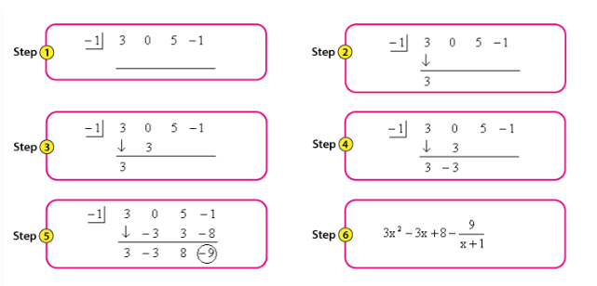

**Fig 1 : Synthetic division**

**1.2 Challenges**

To implement this project I had to face some unique challenges. I used the remainder theorem to simulate how a human would solve the equation using the remainder theorem. Hence there were a lot of unexpected errors and corner cases where I was often stuck.Other challenges :

● To solve the polynomial equation, I used here the Bairstow algorithm for finding real and rational roots.There I faceed challenge for removing epsilon error from roots.

● It was challenge to calculate the complex root of polynomial equation.

● Processing linear equations and generating the necessary intermediate steps to get to the solution.

● Calculating points for plotting the graph of a given linear and polynomial expression. ● It was also a challenge to handle these huge lines of code and different files. **2. Project Overview & Description**

**2.1 Separate number and variable**

Users can input equations in any format. So, we should tokenize this number and variable and the power of the variable. Then store it in a matrix array /vector for calculation and find the solution of linear equation and polynomial equation.

**2.2 Solution of linear equation**

After tokenizing numbers and variables, we make a matrix and finds determine this matrix. Then replace one column of the matrix with its constant vector and also find determinant of this

6

matrix. We found determinant value for each variable. Here Cramer’s rule is used to find the unique solution to these equations.

**2.3 Infinite/ No solution exists**

If the determinant value of the first matrix is equal to zero then there are infinitely many solutions or no solution exists. Now we check the constant vector, if the constant vector is a multiplicand of the first matrix then there are infinitely many solutions exist. Otherwise, there are no solutions exists.

**2.4 Polynomial equation**

We use Bairstow method for solving a polynomial equation. To solve the polynomial equation we use a quadratic equation. We divide the main equation with the quadratic equation, if the remainder is equal to zero then we find two roots from the quadratic equation and the main equation will be lower two degrees. We again use the new equation as the main equation and find a new quadratic equation which is also the root of the main equation. We proceed with this until our equation becomes quadratic or with less power. *Fig 2* shows the process :

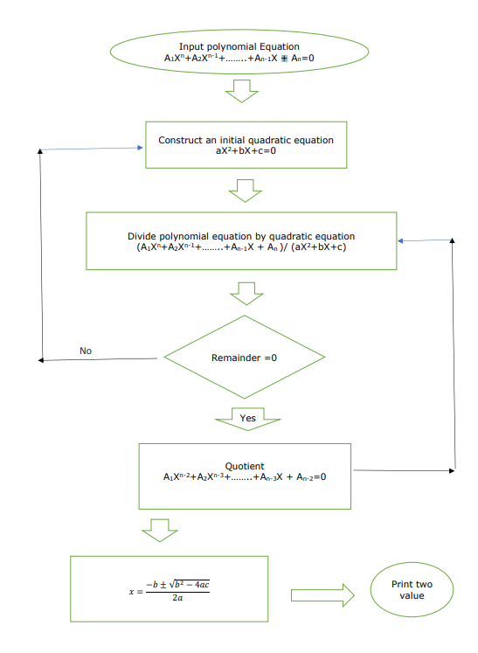

**Fig 2 : Polynomial equation solving flow chart**

7

The program tries to show the steps taken by a human who is trying to analyze a given polynomial expression. Thus while trying to solve a given expression the program frequently outputs the current state of the given expression so the user can keep track of the whole process.

First it takes the user input. After getting the standard string input I had to take the input string and parse the string to separate variables from coefficients and operators, braces and other symbols. Since it manipulates the polynomial expression as simple term, It creates a custom container class named “Term” which contains all of the information of a polynomial term. This makes accessing and manipulating the given expression very simpler and more close to how a human would analyze the expression.

After parsing the terms from given input it determines the degree of the polynomial expression. If polynomial expression has a degree equal or lower than 2 then the sequence of terms are forwarded to “Process Linear Equation” or “Process Quadratic Equation” according to the degree of the given input.(*Fig 3* shows the process ).

For a linear equation the program calculates the value of the root. First the constant terms and the terms containing variables are separated. The variables are contained to the left and the constant terms are contained at the right side of the equal sign of the equation. Then the program iteratively adds the variables and constant terms with each other to shorten each side. Then just a simple division at both sides by the variable coefficient gives us the desired root.

For a quadratic equation the program first substitutes all terms to the left side of the equation. Then the program converts the given expression into the standard form of polynomial expressions.

Then the program applies the remainder theorem to find a root for the given expression. After it finds a suitable root for the equation the program converts the equation to a form where it can extract the factor from that equation. Depending on the degree of the remaining polynomial factor the same process may be used as many times as needed. After all extracted factors are of degree 1 the program will return the solution and all the intermediate steps.

Below are the actions taken by the program shown with a simple diagram.(*Fig 3* ) 8

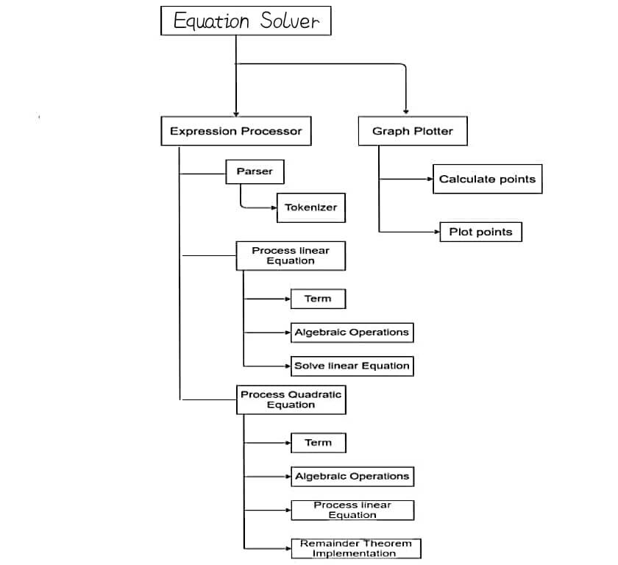**Fig 3: Simple chart showing all the actions taken by the program**

**3. User manual**

Here users can easily access any feature using the command line.

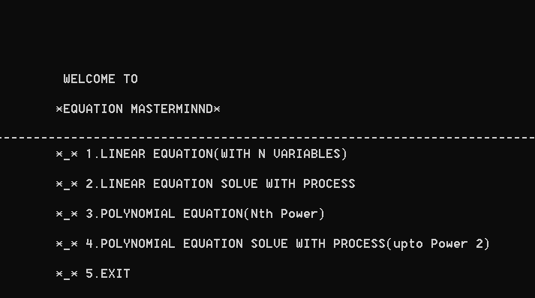**Fig 4 : User Interface**

9

In linear programming, the user can input equations without any modification. then it will take input “ The number of variable “. We need same number of equations. then solve it & shows output the roots .

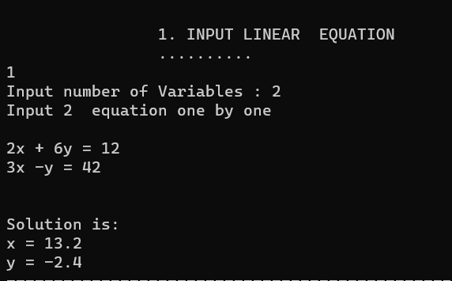**Fig 5: Linear Equation solve**

User can see how to solve linear equation step by step using cremer’s rule

**Fig 6: Linear equation solve step by step**

10

**Fig 7: Linear equation solve step by step**

If we select 2 , then it will require “ Polynomial equation” as input. We can input in polynomial expression.

**Fig 8: Polynomial Equation solution**

then click on “ Enter “ button & get solutions. If there is any complex solution , it will also handle this. See this pic to understand what happens.



**Fig 9: Polynomial Equation solution( complex root)**

After this we will enter “ Step By Step Solution System “. Here we will get full solution process of linear equation and quadratic equation solution.

If we input a linear equation , it shows process of solution.

11

**Fig 10: Polynomial equation( single variable) solve step by step**

If user input a quadratic equation , it shows solution process.

**Fig 11: Quadratic equation solve step by step**

Besides , we can plot graph of linear function and polynomial fun

**4. Conclusion**

There are many equations in mathematics, and my project try to solve some selective equations. I try my best to find solutions properly of these equations. I use different types of equations to test this solution. All tests have become successful and it makes a strong proof that this project worked successfully.

From the beginning of this project, I wanted to simulate the process of analyzing a polynomial function using the remainder theorem. The process of finding the factors of a higher degree expression and reducing the function bit by bit manually seen a bit tedious. So in my project I wanted to automate this process. Although limited, I think I have succeeded in simulating the remainder theorem process. Throughout the project I had to face a lot of problems specially at parsing the given input, as anyone can give any combination of terms to generate a polynomial expression .

I tried to learn and implement everything from scratch. Working on this project has helped me have a better idea about windows and network programming. Being new to this programming paradigm, this SPL has challenged my limits. I enjoyed learning on the go and implementing it. I am happy that I could complete the project successfully and have taken on the challenges. I find myself more confident while solving yet the unseen problem, thinking critically, and I believe the experience from this project made me more capable for any future projects that I might work on.

13

**References**

⮚ My Git hub repository :

https://github.com/Jihad011/SPL-1

⮚ Polynomial Remainder theorem : https://en.wikipedia.org/wiki/Polynomial_remainder_theorem ⮚ Synthetic division : https://en.wikipedia.org/wiki/Synthetic_division

⮚ Bairstow method:

https://math.iitm.ac.in/public_html/sryedida/caimna/transcendental/polynomial%20methods/brs%20 method.html

⮚ Polynomial equation : https://www.calculatorsoup.com/calculators/math/math-equation-solver.php ⮚ Linear programming: https://en.wikipedia.org/wiki/Simplex_algorithm

⮚ Cremer’s Rule : 9.8: Solving Systems with Cramer's Rule - Mathematics LibreTexts 14